**AeroFit Treadmill Sales Analysis Report**

**Table of Contents**

1. Summary
2. Introduction
3. Data Description
4. Statistical Summary
   * Numerical Features Summary
   * Categorical Features Summary
5. Key Observations
6. Data Analysis
   * Product vs Gender
   * Product vs Age
   * Product vs Income
   * Product vs Fitness Level
   * Product vs Marital Status
7. Data Visulization
8. Actionable Insights & Recommendations
9. Conclusion

**Summary**

The market research team at AeroFit analyzed customer data to identify the characteristics of target audiences for different treadmill models. This report provides statistical insights into customer demographics, product preferences, and purchasing behavior. Actionable recommendations are provided to optimize marketing strategies and increase sales.

**Introduction**

AeroFit offers three treadmill models:

* **KP281**: Entry-level, priced at $1,500
* **KP481**: Mid-range, priced at $1,750
* **KP781**: Advanced, priced at $2,500

The objective is to understand customer preferences and recommend treadmills based on demographic and behavioral characteristics.

**Data Description**

The dataset consists of customer details collected over the past three months. Key features include:

* **Product**: Purchased treadmill model
* **Age**: Customer's age
* **Gender**: Male/Female
* **Education**: Years of education completed
* **MaritalStatus**: Single or partnered
* **Usage**: Weekly treadmill usage
* **Fitness**: Self-rated fitness level (1-5 scale)
* **Income**: Annual income (USD)
* **Miles**: Expected weekly mileage

**Statistical Summary**

**Numerical Features Summary**

* Age range: **18 to 50 years** (Average: **28.8**)
* Education: **12 to 21 years** (Average: **16**)
* Income: **$29K – $104K**, with significant variance
* Usage frequency: **2-7 times per week**
* Fitness levels: **1 to 5 scale**, centered around **3-4**
* Miles per week: **21–360 miles**, showing varied engagement levels

**Categorical Features Summary**

* **Product Preference**: Distribution across KP281, KP481, KP781
* **Gender Distribution**: Male vs Female purchases
* **Marital Status**: Partnered vs Single buyers

**Key Observations**

* Majority of buyers are **20 to 30 years old**
* Higher education levels correlate with greater fitness awareness
* Customers prefer exercising **2-3 times per week**
* Most customers have an income range of **$30K to $60K**
* The **KP281** treadmill has the highest sales, indicating affordability preference
* **Male buyers outnumber female buyers**
* **Partnered individuals purchase more treadmills**

**Data Analysis**

**Product vs Gender**

* **Male buyers** purchase more treadmills than female buyers
* **KP781** is more frequently purchased by female buyers

**Product vs Age**

* **20-30 age** group dominates treadmill purchases

**Product vs Income**

* **KP281** is favored by low-income buyers ($30K - $60K**)**
* **KP481** is chosen by mid-income buyers
* **KP781** is bought by high-income customers ($80K+)

**Product vs Fitness Level**

* Customers with fitness level **4 or 5 prefer KP781**
* **Lower fitness levels** correlate with less frequent treadmill usage

**Product vs Marital Status**

* **Partnered** individuals purchase more treadmills than singles

**7. Data Visulization**

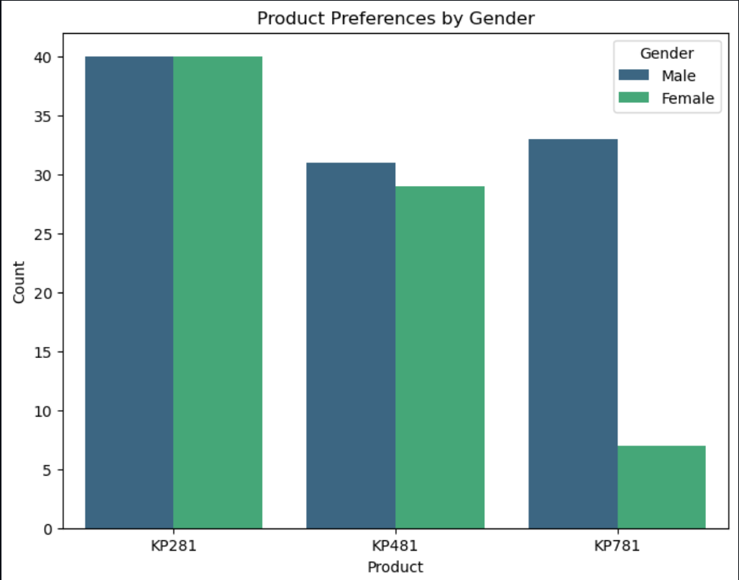

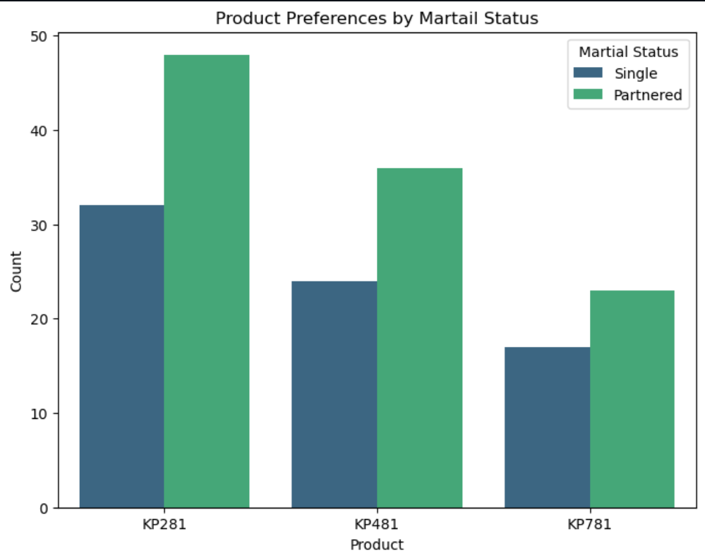

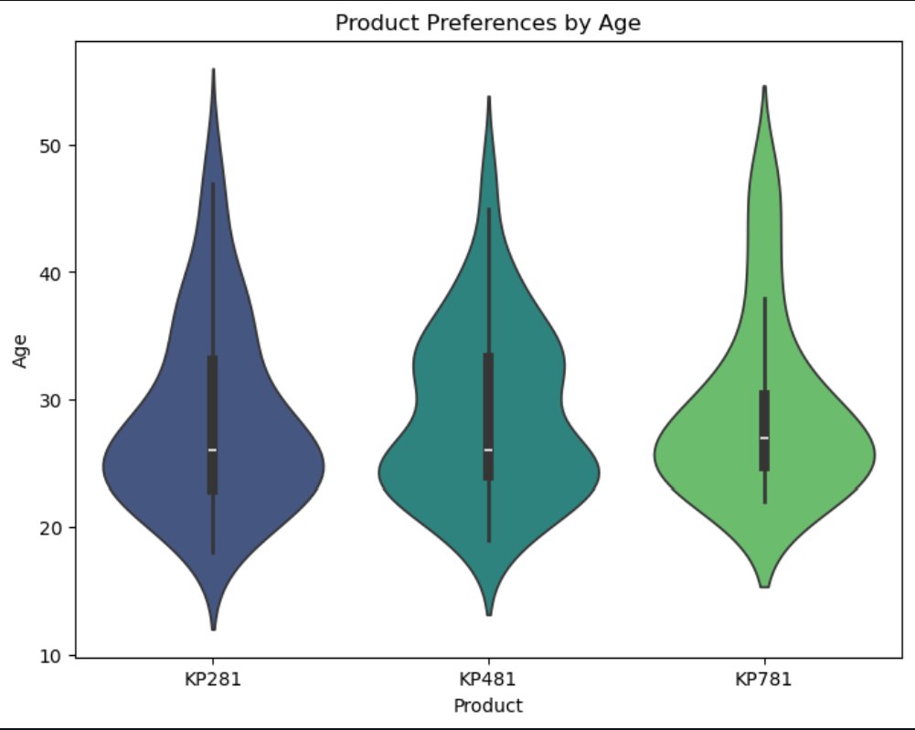

**Actionable Insights & Recommendations**

**Age-Based Targeting**

* **Insight**: Majority of buyers are **20-30 years old**
* **Action**: Focus marketing on university students, professionals, and fitness-conscious millennials

**Income-Based Segmentation**

* **Insight**: KP281 is favored by lower-income buyers, while KP781 attracts high-income buyers
* **Action**:
  + Offer **financing options** to boost KP481 sales
  + Use **premium branding** and exclusive gym partnerships for KP781

**Gender-Based Marketing**

* **Insight**: Male customers dominate treadmill purchases
* **Action**:
  + Launch **women-focused fitness campaigns**
  + Offer **couple/family discounts** to increase female buyer engagement

**Marital Status Influence**

* **Insight**: Partnered individuals are more likely to buy treadmills
* **Action**:
  + Promote **"Couple Fitness Bundles"**
  + Introduce **referral programs** to encourage partner/family purchases

**Fitness Level & Usage Patterns**

* **Insight**: Higher fitness levels correlate with premium treadmill purchases
* **Action**:
  + Target athletes and high-intensity users with **advanced features of KP781**
  + Provide **fitness starter guides** for lower fitness customers

**Usage & Mileage Trends**

* **Insight**: Frequent users prefer high-end models
* **Action**:
  + Promote KP781 for **long-distance runners** with performance-tracking features

**Pricing & Promotion Strategy**

* **Insight**: KP281 is the most popular due to affordability
* **Action**:
  + Introduce **seasonal discounts** on KP481
  + Offer an **upgrade plan** for KP281 buyers to switch to higher-end models

**Conclusion**

The analysis provides key insights into customer demographics and purchasing patterns. To optimize sales, AeroFit should:

* Focus on **targeted marketing** for young adults
* Offer **customized promotions** based on income levels
* Introduce **financing plans** for mid-range models
* Enhance **female-focused campaigns** to increase engagement
* Implement **bundling & referral strategies** for partnered customers

By implementing these strategies, AeroFit can improve sales and customer satisfaction while effectively positioning each treadmill model for its ideal audience.